**Carleton North High School**

30 School Street

Florenceville-Bristol, N.B.

E7L 2G2

Phone: (506) 392-5120 Fax: (506) 392-5113

Jason Smith **Principal** Jana Brennan **Vice - Principal**

September 8, 2020

**Re: Safety**

Dear Families of CNHS Students and Bus Drivers:

Welcome back to school! We are glad you are with us. ☺ At this point in the year, it is important for us to share some valuable reminders that will help to keep our students safe.

We have 23 buses delivering and picking up students at CNHS. As such, our parking lot and bus loading zone can be congested with the number of buses, vehicles, student drivers and walking students moving through the area. Therefore, we kindly ask the following of you at arrival and dismissal times:

1. **Use the designated drop off area** in the mornings and **exit to the back** (right) of the student parking lot (as seen in the diagram on the back of this sheet) at bus times - avoiding buses entering the loading zone;
2. Pick up students in the student parking lot at the end of the day **after 3:12** p.m. in order to avoid getting caught in traffic and to allow buses to come and go in a safe and orderly manner;
3. **Refrain from driving around the school** at arrival and dismissal times as only buses have permission to do so;
4. **Fill the back part of the student parking lot first** which makes for less congestion around buses at the front of the parking lot;
5. Exit the building using the bus loading doors if you are going on a bus. We are only able to load buses in the loading zone;
6. Exit the building using the lobby doors **after the first dismissal bell at 3:00 pm if you are walking home or driving home in a car**. Avoid walking between buses as you exit.

(over)

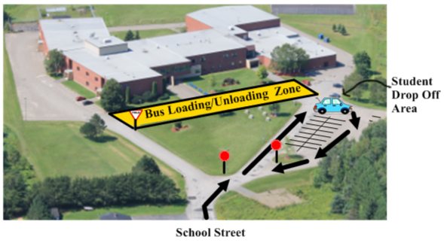

By working together, we can keep everyone safe. Please sign below to indicate that you have read this information and return this portion to your period 1 teacher.

_ _ _ _ _ _ _ _ _ _ _ _ _ _ _ _ _ _ _ _ _ _ _ _ _ _ _ _ _ _ _ _ _ _ _ _ _ _ _ _ _ _ _ _ _ _ _ _ _ _ _ _ _ _ _ _ _ _ _

Student Name: ______________________________________________

Student Signature: ___________________________________________

Parent / Guardian Name: ______________________________________

Parent / Guardian Signature: ___________________________________

**Thank you for your support** in keeping Carleton North students safe,

Jason Smith- **Principal**

Jana Brennan – **Vice Principal**